Lesson | Content
Week 4  Lesson 1 | Ch 1.1: The atom  - Protons, neutrons, electrons  - Diagram  - ^{A}_{z}X  - What holds atoms together?
Week 4  Lesson 2 | Ch 1.2/1.3  - Isotopes  - Calculating average mass number  Students should already know basics of relative atomic mass from Chapter 5
Week 4  Lesson 3&4 | Ch 1.4:  - Arrangement of periodic table (groups, periods)  - Why elements are grouped together (properties, which in turn is due to electron arrangement)  - Names of groups: Alkali, Alkaline Earth, Halogens, Transition metals, Noble gases  - Position of metals, non-metals, semi-metals (metalloids)  Ch 1.6: Electron arrangement  - Electrons found in energy levels called shells  - Representing with shell model up to calcium (2, 8, 8, 2)  - Subshell model is also in book. Only use if you are confident in teaching. Syllabus does not specify whether to use shell model or sub-shell model  - Relationship between periodic table and electron arrangement (see first section of Ch 1.7)  - Representations: Cloud diagrams, electron shell diagrams (atomic orbital shapes not required)  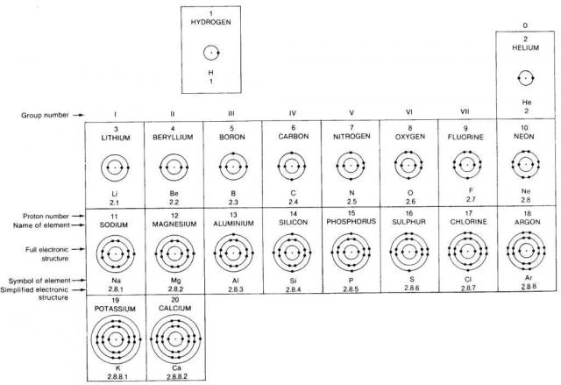
Week 5  Lesson 1 | Ch 1.7: Atomic trends
Week 5  Lesson 2 | Ch 1.8: Elemental spectra
Week 5  Lesson 3 | Prac: Flame tests

Mass spectrometry and AAS don’t need to be covered in class – Students can research for assignment.

